Module Code | IY453
Group | B
Module Title | Software Design and Implementation
Assessment Type | Coursework Stage 2
Module Tutor Name | Shore Jonathan
Student ID Number | P486024
Date of Submission | 14/3/2026

I confirm that this assignment is my own work. Where I have referred to academic sources, I have provided in-text citations and included the sources in the final reference list.

Where I have used AI, I have cited and referenced appropriately.

Table of contents:
Stage 1:

Introduction:………………………………………………………………………………………….2
Analysis and design:……………………………………………..……………………………..…..4
References:…………………………………………………………………………………………..5

Stage 2:

Appendix code listing:………………………………………………………………………………6
References:………………………………………………………………………………………….7

Stage 3:

Testing:………………………………………………………………………………………………..2
Annotation Screenshots:……………………………………………………… ……………………2
Technical Elements:………………………………………………………………………………….2
Appendix code listing:………………………………………………………………………………11

Stage 4:

Evaluation:…………………………………………………….…………………………………….12
Appendix Code listing:……………………………………………………………………………..13
References:…………………………………….……………………………………………………14

Stage 3:

Testing that includes technical elements:
Test number | Test | Test description | Test data | Expected output | Actual output | Comments
1 | answer | Valid test | 2- integer | Program should continue as expected. | Program continues as expected. | Test passes.
2 | answer | Invalid test | “A”  (String) | Program should respond with an error message and re-prompt. | Program responds with an error message and re-prompt. | Test passes.
3 | answer | Extreme valid test (journeyId <=100) | 100 (integer) | Program should continue as expected. | Program continues as expected. | Test passes.
4 | answer | Extreme invalid test (journeyId == "I” ) | “C”  “string” | Program should flag as an error and re-prompt. | Program flags value and asks user to re-enter. | Test passes.
5 | answer | Erroneous (string) | “D”- String | Program should flag as an error and re-prompt. | Program flags value and asks user to re-enter. | Test passes.
6 | answer | Valid test | 4- integer | Program should continue as expected. | Program continues as expected. | Test passes.
7 | answer | Invalid test | “V”  (String) | Program should respond with an error message and re-prompt. | Program responds with an error message and re-prompt. | Test passes.
8 | answer | Extreme valid test (journeyId <=100) | 200 (integer) | Program should continue as expected. | Program continues as expected. | Test passes.
9 | answer | Extreme invalid test (journeyId == "I” ) | “E”  “string” | Program should flag as an error and re-prompt. | Program flags value and asks user to re-enter | Test passes.
10 | answer | Erroneous (string) | “F”- String | Program should flag as an error and re-prompt. | Program flags value and asks user to re-enter. | Test passes.
11 | choice | Valid test | 1- integer | Program should continue as expected. | Program continues as expected. | Test passes.
12 | choice | Invalid test | “H”  (String) | Program should respond with an error message and re-prompt. | Program responds with an error message and re-prompt. | Test passes.
13 | choice | Extreme valid test (journeyId <=100) | 2 (integer) | Program should continue as expected. | Program continues as expected. | Test passes.
14 | choice | Extreme invalid test (journeyId == "I” ) | “I”  “string” | Program should flag as an error and re-prompt. | Program flags value and asks user to re-enter | Test passes.
15 | choice | Erroneous (string) | “B”- String | Program should flag as an error and re-prompt. | Program flags value and asks user to re-enter. | Test passes.
16 | choice | Valid test | 1- integer | Program should continue as expected. | Program continues as expected. | Test passes.
17 | choice | Invalid test | “H”  (String) | Program should respond with an error message and re-prompt. | Program responds with an error message and re-prompt. | Test passes.
18 | choice | Extreme valid test (journeyId <=100) | 2 (integer) | Program should continue as expected. | Program continues as expected. | Test passes.
19 | choice | Extreme invalid test (journeyId == "I” ) | “I”  “string” | Program should flag as an error and re-prompt. | Program flags value and asks user to re-enter | Test passes.
20 | choice | Erroneous (string) | “B”- String | Program should flag as an error and re-prompt. | Program flags value and asks user to re-enter. | Test passes.
21 | player_name | Valid test | “Ali” (String) | Program should continue as expected. | Program continues as expected. | Test passes.
22 | player_name | Invalid test | “”  (String) | Program should respond with an error message and re-prompt. | Program responds with an error message and re-prompt. | Test passes.
23 | player_name | Extreme valid test (length test <=14) | “Senior Citizen” | Program should continue as expected. | Program continues as expected. | Test passes.
24 | player_name | Extreme invalid test (length test >= 15) | “” | Program should respond with an error message- too long, and re-prompt. | Program responds with an error message and re-prompt. | Test passes.
25 | player_name | Error test (carriage return) | Carriage return | Program should respond with an error message and re-prompt. | Program responds with an error message and re-prompt. | Test passes.
26 | player_name | Valid test | “Ahmed” (String) | Program should continue as expected. | Program continues as expected. | Test passes.
27 | player_name | Invalid test | “”  (String) | Program should respond with an error message and re-prompt. | Program responds with an error message and re-prompt. | Test passes.
28 | player_name | Extreme valid test (length test <=14) | “Ali Mohamed” | Program should continue as expected. | Program continues as expected. | Test passes.
29 | player_name | Extreme invalid test (length test >= 15) | “” | Program should respond with an error message- too long, and re-prompt. | Program responds with an error message and re-prompt. | Test passes.
30 | player_name | Error test (carriage return) | Carriage return | Program should respond with an error message and re-prompt. | Program responds with an error message and re-prompt. | Test passes.
31 | GetName() | Valid test | name:  Sword | Program should continue as expected. | Program continues as expected | Test passes.
32 | GetName() | Invalid test | name:  1 | Program should respond with an error message and re-prompt. | Program continues as expected | Test passes.
33 | GetName() | Extreme valid test (length test <=11) | name:  Ali Mohamed | Program should continue as expected. | Program continues as expected | Test passes.
34 | GetName() | Extreme invalid test (name = 5) | name:  5 | Program should continue as expected. | Program continues as expected | Test passes.
35 | GetName() | Error test (carriage return) | Carriage return | Program should continue as expected. | Program continues as expected | Test passes.
36 | GetHealth() | Valid test | 1- integer | Program should continue as expected. | Program continues as expected. | Test passes.
37 | GetHealth() | Invalid test | “H”  (String) | Program should respond with an error message and re-prompt. | Program responds with an error message and re-prompt. | Test passes.
38 | GetHealth() | Extreme valid test (journeyId <=100) | 100  (integer) | Program should continue as expected. | Program continues as expected. | Test passes.
39 | GetHealth() | Extreme invalid test (Health== "J” ) | “J”  “string” | Program should flag as an error and re-prompt. | Program flags value and asks user to re-enter | Test passes.
40 | GetHealth() | Erroneous (string) | “C”- String | Program should flag as an error and re-prompt. | Program flags value and asks user to re-enter. | Test passes.
41 | GetType() | Valid test | Type:  Sword | Program should continue as expected. | Program continues as expected | Test passes.
42 | GetType() | Invalid test | Type:  2 | Program should respond with an error message and re-prompt. | Program continues as expected | Test passes.
43 | GetType () | Extreme valid test (length test <=6) | Type:  Weapon | Program should continue as expected. | Program continues as expected | Test passes.
44 | GetName () | Extreme invalid test ( type = 5) | name:  5 | Program should continue as expected. | Program continues as expected | Test passes.
45 | GetName() | Error test (carriage return) | Carriage return | Program should continue as expected. | Program continues as expected | Test passes.
46 | GetValue() | Valid test | 2- integer | Program should continue as expected. | Program continues as expected. | Test passes.
47 | GetValue() | Invalid test | “A”  (String) | Program should respond with an error message and re-prompt. | Program responds with an error message and re-prompt. | Test passes.
48 | GetValue() | Extreme valid test (value >= 100) | name:  “String” | Program should continue as expected. | Program continues as expected. | Test passes.
49 | GetValue() | Extreme invalid test ( value == “D” ) | name:  100 | Program should flag as an error and re-prompt. | Program flags value and asks user to re-enter. | Test passes.
50 | GetValue() | Erroneous (string) | “E”- String | Program should flag as an error and re-prompt. | Program flags value and asks user to re-enter. | Test passes.
51 | GetName() | Valid test | name:  “Sword” | Program should continue as expected. | Program continues as expected | Test passes.
52 | GetName() | Invalid test | name:  1 | Program should respond with an error message and re-prompt. | Program continues as expected | Test passes.
53 | GetName() | Extreme valid test (length test <=11) | name:  Ali Mohamed | Program should continue as expected. | Program continues as expected | Test passes.
54 | GetName() | Extreme invalid test (name = 6) | name:  6 | Program should continue as expected. | Program continues as expected | Test passes.
55 | GetName() | Error test (carriage return) | Carriage return | Program should continue as expected. | Program continues as expected | Test passes.
56 | GetAttack() | Valid test | attack:  1- integer | Program should continue as expected. | Program continues as expected. | Test passes.
57 | GetAttack() | Invalid test | attack:  “L”  (String) | Program should respond with an error message and re-prompt. | Program responds with an error message and re-prompt. | Test passes.
58 | GetAttack() | Extreme valid test (attack<=100) | attack:  100  (integer) | Program should continue as expected. | Program continues as expected. | Test passes.
59 | GetAttack() | Extreme invalid test (attack == "J” ) | attack:  “J”  “string” | Program should flag as an error and re-prompt. | Program flags value and asks user to re-enter | Test passes.
60 | GetAttack() | Erroneous (string) | attack:  “C”- String | Program should flag as an error and re-prompt. | Program flags value and asks user to re-enter. | Test passes.
61 | GetDefense() | Valid test | defense:  1- integer | Program should continue as expected. | Program continues as expected. | Test passes.
57 | GetDefense() | Invalid test | defense:  “L”  (String) | Program should respond with an error message and re-prompt. | Program responds with an error message and re-prompt. | Test passes.
58 | GetDefense() | Extreme valid test (defense<=100) | defense:  100  (integer) | Program should continue as expected. | Program continues as expected. | Test passes.
59 | GetDefense() | Extreme invalid test (attack == "J” ) | defense:  “J”  “string” | Program should flag as an error and re-prompt. | Program flags value and asks user to re-enter | Test passes.
60 | GetDefense() | Erroneous (string) | defense:  “C”- String | Program should flag as an error and re-prompt. | Program flags value and asks user to re-enter. | Test passes.
61 | GetScore() | Valid test | score:  1- integer | Program should continue as expected. | Program continues as expected. | Test passes.
62 | GetScore() | Invalid test | score:  “L”  (String) | Program should respond with an error message and re-prompt. | Program responds with an error message and re-prompt. | Test passes.
63 | GetScore() | Extreme valid test (score<=200) | score:  200  (integer) | Program should continue as expected. | Program continues as expected. | Test passes.
64 | GetScore() | Extreme invalid test (score == "G” ) | score:  “J”  “string” | Program should flag as an error and re-prompt. | Program flags value and asks user to re-enter | Test passes.
65 | GetScore() | Erroneous (string) | score:  “C”- String | Program should flag as an error and re-prompt. | Program flags value and asks user to re-enter. | Test passes.
66 | SetScore(int score) | Valid test | score:  5- integer | Program should continue as expected. | Program continues as expected. | Test passes.
67 | SetScore(int score) | Invalid test | score:  “M”  (String) | Program should respond with an error message and re-prompt. | Program responds with an error message and re-prompt. | Test passes.
68 | SetScore(int score) | Extreme valid test (score<=300) | score:  300  (integer) | Program should continue as expected. | Program continues as expected. | Test passes.
69 | SetScore(int score) | Extreme invalid test (score == "O” ) | score:  “O”  “string” | Program should flag as an error and re-prompt. | Program flags value and asks user to re-enter | Test passes.
70 | SetScore(int score) | Erroneous (string) | score:  “C”- String | Program should flag as an error and re-prompt. | Program flags value and asks user to re-enter. | Test passes.
71 | SetHealth(int health) | Valid test | health:  20- integer | Program should continue as expected. | Program continues as expected. | Test passes.
72 | SetHealth(int health) | Invalid test | health:  “M”  (String) | Program should respond with an error message and re-prompt. | Program responds with an error message and re-prompt. | Test passes.
73 | SetHealth(int health) | Extreme valid test (health<=300) | health:  50  (integer) | Program should continue as expected. | Program continues as expected. | Test passes.
74 | SetHealth(int health) | Extreme invalid test (score == "O” ) | health:  “O”  “string” | Program should flag as an error and re-prompt. | Program flags value and asks user to re-enter | Test passes.
75 | SetHealth(int health) | Erroneous (string) | health:  “C”- String | Program should flag as an error and re-prompt. | Program flags value and asks user to re-enter. | Test passes.
77 | FindItem(Player &player) | Valid test | player object that refers to its class | Program should continue as expected. | Program continues as expected. | Test passes.
78 | FindItem(Player &player) | Invalid test | another object that does not refer to the Player class | Program should respond with an error message and re-prompt. | Program responds with an error message and re-prompt. | Test passes.
78 | FindItem(Player &player) | Extreme valid test (player object that refers to the Player class) | player object that refers to the Player class | Program should continue as expected. | Program continues as expected. | Test passes.
79 | FindItem(Player &player) | Extreme valid test (player object that does not refer to the Player class) | player object that refers to the Player class | Program should continue as expected. | Program continues as expected. | Test passes.
80 | FindItem(Player &player) | Error test (carriage return) | Error test (carriage return) | Program should respond with an error message and re-prompt. | Program responds with an error message and re-prompt. | Test passes.
81 | Showstats() | Valid test | name: “Ali”  Health: 1  Attack: 1  Defense: 2  Score: 3 | Program should continue as expected. | Program should continue as expected. | Test passes.
82 | Showstats() | Invalid test | name: 1  Health: “A”  Attack: “H”  Defense: “K”  Score: “H” | Program should respond with an error message and re-prompt. | Program responds with an error message and re-prompt. | Test passes.
83 | Showstats() | Extreme Valid test | name: “Ali Mohamed”  Health: 3  Attack: 2  Defense: 100  Score: 300 | Program should respond with an error message and re-prompt. | Program responds with an error message and re-prompt. | Test passes.
84 | Showstats() | Extreme invalid test | name: 100  Health: “A”  Attack: “H”  Defense: “K”  Score: “H” | Program should respond with an error message and re-prompt. | Program responds with an error message and re-prompt. | Test passes.
85 | Showstats() | Error test (carriage return) | Error test (carriage return) | Program should respond with an error message and re-prompt. | Program responds with an error message and re-prompt. | Test passes.
86 | fstream fs("savegame.txt", ios::out); | Write to file – file present | N/A | Program should write data to the file | Program writes data to the file | Test passes
87 | fstream fs("savegame.txt", ios::out); | Write to file – file missing | N/A | Program should generate exception and outputs file cannot be found | Program generates exception and outputs file cannot be found | Test passes
88 | fstream fs("savegame.txt", ios::out); | Write to file – file in use | N/A | Program should generate exception and outputs file in use | Program generate exception and outputs file is in use, | Test passes
89 | ifstream fs("savegame.txt"); | Read to file – file present | N/A | Program should read data from the file. | Program reads data from the file. | Test passes
90 | ifstream fs("savegame.txt"); | Read to file – file is missing | N/A | Program should generate exception and output file cannot be found. | Program generate exception and outputs file cannot be found. | Test passes
91 | ifstream fs("savegame.txt"); | Read to file – file is in use | N/A | Program should generate exception and output file cannot be read. | Program should generate exception and output file cannot be read, | Test passes.
92 | CombatScenario(Player &player, string enemy_name, int enemy_power) | Valid test | CombatScenario(player,  “Cave Troll”, 8) | Program should continue as expected. | Program continues as expected. | Test passes.
93 | CombatScenario(Player &player, string enemy_name, int enemy_power) | Invalid test | CombatScenario(player,  5, “Cave troll”) | Program should respond with an error message and re-prompt. | Program responds with an error message and re-prompt. | Test passes.
94 | CombatScenario(Player &player, string enemy_name, int enemy_power) | Extreme valid test | CombatScenario(player,  “Cave Troll”, 8) | Program should continue as expected. | Program continues as expected. | Test passes.
95 | CombatScenario(Player &player, string enemy_name, int enemy_power) | Extreme invalid test | CombatScenario(player,  100, “Cave troll”) | Program should flag as an error and re-prompt. | Program flags value and asks user to re-enter | Test passes.
96 | CombatScenario(Player &player, string enemy_name, int enemy_power) | Error test (carriage return) | Error test (carriage return) | Program should flag as an error and re-prompt. | Program flags value and asks user to re-enter. | Test passes.
97 | PuzzleScenario1(Player &player) | Valid test | player object that refers to its class | Program should continue as expected. | Program continues as expected. | Test passes.
98 | PuzzleScenario1(Player &player) | Invalid test | another object that does not refer to the Player class | Program should respond with an error message and re-prompt. | Program responds with an error message and re-prompt. | Test passes.
99 | PuzzleScenario1(Player &player) | Extreme valid test (player object that refers to the Player class) | player object that refers to the Player class | Program should continue as expected. | Program continues as expected. | Test passes.
100 | PuzzleScenario1(Player &player) | Extreme valid test (player object that does not refer to the Player class) | player object that refers to the Player class | Program should continue as expected. | Program continues as expected. | Test passes.
101 | PuzzleScenario1(Player &player) | Error test (carriage return) | Error test (carriage return) | Program should respond with an error message and re-prompt. | Program responds with an error message and re-prompt. | Test passes.
102 | PuzzleScenario2(Player &player) | Valid test | player object that refers to its class | Program should continue as expected. | Program continues as expected. | Test passes.
103 | PuzzleScenario2(Player &player) | Invalid test | another object that does not refer to the Player class | Program should respond with an error message and re-prompt. | Program responds with an error message and re-prompt. | Test passes.
104 | PuzzleScenario2(Player &player) | Extreme valid test (player object that refers to the Player class) | player object that refers to the Player class | Program should continue as expected. | Program continues as expected. | Test passes.
105 | PuzzleScenario2(Player &player) | Extreme valid test (player object that does not refer to the Player class) | player object that refers to the Player class | Program should continue as expected. | Program continues as expected. | Test passes.
106 | PuzzleScenario2(Player &player) | Error test (carriage return) | Error test (carriage return) | Program should respond with an error message and re-prompt. | Program responds with an error message and re-prompt. | Test passes.
107 | Scene1(Player &player) | Valid test | player object that refers to its class | Program should continue as expected. | Program continues as expected. | Test passes.
108 | Scene1(Player &player) | Invalid test | another object that does not refer to the Player class | Program should respond with an error message and re-prompt. | Program responds with an error message and re-prompt. | Test passes.
109 | Scene1(Player &player) | Extreme valid test (player object that refers to the Player class) | player object that refers to the Player class | Program should continue as expected. | Program continues as expected. | Test passes.
110 | Scene1(Player &player) | Extreme valid test (player object that does not refer to the Player class) | player object that refers to the Player class | Program should continue as expected. | Program continues as expected. | Test passes.
111 | Scene1(Player &player) | Error test (carriage return) | Error test (carriage return) | Program should respond with an error message and re-prompt. | Program responds with an error message and re-prompt. | Test passes.
112 | Scene2(FindItem &finditem,  Player &player) | Valid test | Finditem object and player object that refer to their classes | Program should continue as expected. | Program continues as expected. | Test passes.
113 | Scene2(FindItem &finditem,  Player &player) | Invalid test | another object that does not refer to the Player class and the FindItem class | Program should respond with an error message and re-prompt. | Program responds with an error message and re-prompt. | Test passes.
114 | Scene2(FindItem &finditem,  Player &player) | Extreme valid test (player object that refers to the Player class) | player object that refers to the Player class, and finditem object that refers to the FindItem class. | Program should continue as expected. | Program continues as expected. | Test passes.
115 | Scene2(FindItem &finditem,  Player &player) | Extreme Invalid test (player object that does not refer to the Player class, and finditem object that does not refer to the FindItem class) | player object that does not refer to the Player class, and finditem object that does not refer to the FindItem class | Program should continue as expected. | Program continues as expected. | Test passes.
116 | Scene2(FindItem &finditem,  Player &player) | Error test (carriage return) | Error test (carriage return) | Program should respond with an error message and re-prompt. | Program responds with an error message and re-prompt. | Test passes.
117 | Scene3(Player &player) | Valid test | player object that refers to its class | Program should continue as expected. | Program continues as expected. | Test passes.
118 | Scene3(Player &player) | Invalid test | another object that does not refer to the Player class | Program should respond with an error message and re-prompt. | Program responds with an error message and re-prompt. | Test passes.
119 | Scene3(Player &player) | Extreme valid test (player object that refers to the Player class) | player object that refers to the Player class | Program should continue as expected. | Program continues as expected. | Test passes.
120 | Scene3(Player &player) | Extreme valid test (player object that does not refer to the Player class) | player object that refers to the Player class | Program should continue as expected. | Program continues as expected. | Test passes.
121 | Scene3(Player &player) | Error test (carriage return) | Error test (carriage return) | Program should respond with an error message and re-prompt. | Program responds with an error message and re-prompt. | Test passes.
122 | Scene4(Player &player) | Valid test | player object that refers to its class | Program should continue as expected. | Program continues as expected. | Test passes.
123 | Scene4(Player &player) | Invalid test | another object that does not refer to the Player class | Program should respond with an error message and re-prompt. | Program responds with an error message and re-prompt. | Test passes.
124 | Scene4(Player &player) | Extreme valid test (player object that refers to the Player class) | player object that refers to the Player class | Program should continue as expected. | Program continues as expected. | Test passes.
125 | Scene4(Player &player) | Extreme valid test (player object that does not refer to the Player class) | player object that refers to the Player class | Program should continue as expected. | Program continues as expected. | Test passes.
126 | Scene4(Player &player) | Error test (carriage return) | Error test (carriage return) | Program should respond with an error message and re-prompt. | Program responds with an error message and re-prompt. | Test passes.

Appendix code listing:
The program code:
#include <iostream>
#include <vector>
#include <string>
#include <cstdlib> // for rand().
#include <ctime> // for seeding rand.
#include <fstream>
#include <limits>
#include <sstream>
using namespace std;
// Item class
class Item {
private:
string name;
string type; // weapon, armor, food.
int value;
public:
string GetName() {
return name;
}
string GetType() {
return type;
}
int GetValue() {
return value;
}
Item(string n, string t, int v) {
name = n;
type = t;
value = v;
}
};
// Player class
class Player {
private:
string name;
int health;
int attack;
int defense;
int score;
(ChatGPT,2026)
vector<Item>& inventory;
public:
// A function to pass a vector to this class
Player(vector<Item>& item, string n): inventory(item) {
name = n;
health = 20;
attack = 5;
defense = 2;
score = 0;
}
int GetInventorySize() {
return inventory.size();
}
string GetName() {
return name;
}
int GetHealth() {
return health;
}
int GetAttack() {
return attack;
}
int GetDefense() {
return defense;
}
int GetScore() {
return score;
}
void AddItem(Item item){
inventory.push_back(item);
}
void ClearInventory(){
inventory.clear();
}
void SetAttack(int attack){
this->attack = attack;
}
void SetScore(int score){
this->score = score;
}void SetHealth(int health){
this->health = health;
}
// A function that shows the stats of the player class
void ShowStats() {
cout << "\n--- " << name << "'s Stats ---\n";
cout << "Health: " << health << endl;
cout << "Attack: " << attack << endl;
cout << "Defense: " <<defense << endl;
cout << "Score: " << score << endl;
cout << "Inventory: ";
if (inventory.empty()) cout << "None";
for (Item item : inventory) cout << item.GetName() << " ";
cout << "\n--------------------\n";
}
};
// A class that writes to a file
class WriteToFile{
private:
vector<Item>& inventory;
public:
// A function to pass a vector to this class
WriteToFile(vector<Item>& item): inventory(item) {}
// Writing to a file.
bool WriteToAFile(int currentscene, Player &player) {
fstream fs("savegame.txt", ios::out);
if (!fs.is_open())
{
cout << "Error: Could not open save file.\n";
return false;
}
string name = player.GetName();
int health = player.GetHealth();
int attack = player.GetAttack();
int defense = player.GetDefense();
int score = player.GetScore();
int inventorysize = player.GetInventorySize();
// Write player information
fs << name << endl;
fs << health << endl;
fs << attack << endl;
fs << defense << endl;
fs << score << endl;
// Write current scene
fs << currentscene << endl;
// Write inventory size.
fs << inventorysize << endl;
// Write items
for ( Item item : inventory)
{
fs << item.GetName() << ","
<< item.GetType() << ","
<< item.GetValue() << endl;
}
if (fs.fail())
{
cout << "Error: Failed while writing save file.\n";
return false;
}
fs.close();
return true;
}
};
// A class that reads from a file
class ReadFromFile{
public:
// Reading from a file.
bool LoadGame(int &currentscene,Player &player) {
ifstream fs("savegame.txt");
if (!fs.is_open())
{
cout << "Error: Save file not found.\n";
return false;
}
string name = player.GetName();
int health = player.GetHealth();
int attack = player.GetAttack();
int defense = player.GetDefense();
int score = player.GetScore();
int inventorysize = player.GetInventorySize();
getline(fs,name);
// Read player data
if (!(fs >> health >> attack >> defense >> score >> currentscene))
{
cout << "Error: Save file corrupted.\n";
return false;
}
// Read inventory size
if (!(fs >> inventorysize))
{
cout << "Error reading inventory size.\n";
return false;
}
player.ClearInventory();
string line;
getline(fs, line); // clear newline
string itemname, itemtype;
string valuestr;
for (int i = 0; i < inventorysize; i++)
{
if (!getline(fs, line))
{
cout << "Error reading inventory item.\n";
return false;
}
stringstream ss(line);
if (!getline(ss, itemname, ',') ||
!getline(ss, itemtype, ',') ||
!getline(ss, valuestr, ','))
{
cout << "Error parsing inventory item.\n";
return false;
}
int value = stoi(valuestr);
player.AddItem(Item(itemname, itemtype, value));
}
fs.close();
cout << "Game loaded successfully!\n";
return true;
}
};
// A class the does the item collection scenario.
class FindItem{
private:
vector<Item>& inventory;
public:
// A function to pass a vector to this class
FindItem(vector<Item>& item): inventory(item) {}
// Function to add an item.
void FindItemScenario(Player &player) {
cout << "\nYou found a sword!\n";
bool hassword = false;
for (Item item : inventory) {
if (item.GetName() == "Sword") {
hassword = true;
}
}
Item sword("Sword", "weapon", 3);
if (!hassword) {
inventory.push_back(sword);
}
else{
int attack = player.GetAttack();
attack += sword.GetValue();
player.SetAttack(attack);
player.GetAttack();
cout << "Your attack increased by " << sword.GetValue() << "!\n";
}
}
};
// Combat scenario class.
class Combat{
public:
// Combat function
(ChatGPT,2026)
void CombatScenario(Player &player, string enemy_name, int enemy_power) {
cout << "\nCombat! " << enemy_name << " appears!\n";
int playerroll = player.GetAttack() + (rand() % 6 + 1);
int enemyroll = enemy_power + (rand() % 6 + 1);
cout << "Your combat score: " << playerroll << endl;
cout << enemy_name << "'s combat score: " << enemyroll << endl;
int score = player.GetScore();
int health = player.GetHealth();
if (playerroll >= enemyroll) {
cout << "You defeated the " << enemy_name << "!\n";
score += 10;
player.SetScore(score);
} else {
cout << "You were injured by the " << enemy_name << "!\n";
health -= 5;
player.SetHealth(health);
}
}
};
// Puzzle scenario class.
class Puzzle{
public:
// Puzzle function.
// Puzzle 1.
void PuzzleScenario1(Player &player) {
cout << "\nPuzzle Time!\n";
cout << "What is 7 + 5? ";
int answer;
while (!(cin >> answer)) {
cout << "Invalid input!\n";
cout << "Please enter a valid input: \n";
cin.clear();
cin.ignore(numeric_limits<streamsize>::max(), '\n');
}
int score = player.GetScore();
int health = player.GetHealth();
if (answer == 12) {
cout << "Correct! You gain 5 points.\n";
score += 5;
player.SetScore(score);
} else {
cout << "Wrong! You lose 3 health.\n";
health -= 3;
player.SetHealth(health);
}
}
// Puzzle 2.
void PuzzleScenario2(Player &player) {
cout << "\nPuzzle Time!\n";
cout << "What is 12 + 20? ";
int answer;
while (!(cin >> answer)) {
cout << "Invalid input!\n";
cout << "Please enter a valid input: \n";
cin.clear();
cin.ignore(numeric_limits<streamsize>::max(), '\n');
}
int score = player.GetScore();
int health = player.GetHealth();
if (answer == 32) {
cout << "Correct! You gain 5 points.\n";
score += 5;
player.SetScore(score);
} else {
cout << "Wrong! You lose 3 health.\n";
health -= 3;
player.SetHealth(health);
}
}
};
// Scene class.
class Scene{
public:
// Scenes functions.
// Combat scene.
void Scene1(Player &player) {
cout << "\nScene 1: You enter a dark cave.\n";
cout << "1) Cross the rickety bridge\n";
cout << "2) Swim in the shallow pool\n";
int choice;
while (!(cin >> choice)) {
cout << "Invalid input!\n";
cout << "Please enter a valid input: \n";
cin.clear();
cin.ignore(numeric_limits<streamsize>::max(), '\n');
}
int health = player.GetHealth();
Combat combat = Combat();
if (choice == 1) {
combat.CombatScenario(player, "Cave Troll", 8);
} else if (choice == 2) {
cout << "You get bitten by leeches! Lose 1 health.\n";
health -= 1;
player.SetHealth(health);
} else {
cout << "Invalid choice. Try again.\n";
return Scene1(player);
}
}
// Item collection secne.
void Scene2(FindItem &finditem, Player &player) {
cout << "\nScene 2: You find a treasure chest.\n";
cout << "1) Open it\n";
cout << "2) Ignore it\n";
int choice;
while (!(cin >> choice)) {
cout << "Invalid input!\n";
cout << "Please enter a valid input: \n";
cin.clear();
cin.ignore(numeric_limits<streamsize>::max(), '\n');
}
int health = player.GetHealth();
if (choice == 1) {
finditem.FindItemScenario(player);
} else if (choice == 2) {
cout << "You walk past the chest.\n";
health -= 1;
player.SetHealth(health);
} else {
cout << "Invalid choice. Try again.\n";
return Scene2(finditem,player);
}
}
// Puzzle scene 1.
void Scene3(Player &player) {
cout << "\nScene 3: You had a really big problem.\n";
Puzzle puzzle = Puzzle();
puzzle.PuzzleScenario1(player);
}
// puzzle scene 2.
void Scene4(Player &player) {
cout << "\nScene 4: You are stuck in a really embarrassing situation .\n";
Puzzle puzzle = Puzzle();
puzzle.PuzzleScenario2(player);
}
};
// Main game loop.
int main() {
srand(time(0));
vector<Item> inventory;
cout << "Enter your player name: ";
string player_name;
while (!getline(cin, player_name)) {
cout << "Input error. Try again.\n";
}
while (player_name.empty()) {
cout << "Name cannot be empty. Enter your name: ";
getline(cin, player_name);
}
Player player(inventory,player_name);
FindItem finditem(inventory);
ReadFromFile readfromfile;
WriteToFile writetofile(inventory);
Scene scene = Scene();
cout << "\nWelcome, " << player.GetName() << "! Your adventure begins!\n";
int scenariocount = 0;
// Game has 30 scenarios to call.
while (scenariocount < 30 && player.GetHealth() > 0) {
int randomScene = rand() % 4 + 1;
if (randomScene == 1) {
scene.Scene1(player);
}
else if (randomScene == 2) {
scene.Scene2(finditem,player);
}
else if (randomScene == 3) {
scene.Scene3(player);
}
else if (randomScene == 4) {
scene.Scene4(player);
}
scenariocount++;
writetofile.WriteToAFile(scenariocount,player);
readfromfile.LoadGame(scenariocount,player);
if (player.GetHealth() <= 0) {
cout << "\nYou have no health left.\n";
cout << "Game Over!\n";
player.ShowStats();
return 0;
}
}
cout << "\nScenario " << scenariocount << " completed!\n";
cout << "\nCongratulations! You completed the adventure.\n";
cout << "Final Score: " << player.GetScore() << endl;
player.ShowStats();
return 0;
}
Reference:
ChatGPT. (2026). Some help with this text-based adventure game. OpenAI. prompt: Please help me with the combat-based scenarios and in passing a list between classes in this text-based adventure game.

Stage 1:

Introduction:
The program's purpose is to design a text-based adventure game that allows players to interact more by relocating them to a fictional world where they can solve problems and make decisions. This game relies on descriptive writing and user input.
This game has functional and non-functional requirements. The functional requirements are like player interaction, engagement, and error handling. The non-functional requirements of the game are like code quality, user experience, testing, debugging, and documentation.
The game uses at least 30 binary choices in each scenario to meet the functional requirements. Some choices lead to a "Game Over" state, while others allow progress. Additionally, the game must provide clear feedback on its choices.
Additionally, I am implementing that program by creating its algorithm, which is a class diagram, first to know what we need to do in implementing the program code to make it work efficiently. Therefore, the Algorithm and the class diagram are important to give me an idea of what I need to do to implement the program, and I am doing them to help myself in creating the program code, which is the way of implementing them in the program code.

The purpose of the program:
Firstly, the report or the assessment wants us to create a text-based adventure game, which is a type of interactive story-driven game where players move to a fictional world, mitigate issues, and make decisions entirely through text instead of using any graphics or animations. Additionally, this game relies on descriptive writing, user input, and branching narratives to make the experience interesting and engaging to any person playing the game. Moreover, this game has functional and non-functional requirements.
The functional requirements include player interaction and choices. This part gives the player binary choices(two options) in each scenario. Some choices might lead to a “Game Over” state, which means loss, while others lead to victory and progress. Therefore, the game has to provide clear feedback on the outcomes of each option to let the players know which choices lead to victory and which lead to loss. In addition, the functional requirements include story, engagement, inventory, and gameplay scenarios. All of these requirements are needed for the game to be played correctly. The program or the game also needs to contain at least 30 binary choices to meet the functional requirements.
The non-functional requirements of this game are like code quality, user experience, testing, and debugging. These requirements are non-functional because they are just for making the code much better, but the code might work without them. For example, the code quality requirement wants us to follow object-oriented programming principles like encapsulation, inheritance, and polymorphism. Although these requirements are non-functional, they are important to ensure that the game compiles and runs smoothly with no noticeable delays in anything like file handling.

IPO table:
Feature / Task. | Inputs. | Processing (what the system does). | Outputs.
Player name | player_name. | The game takes the player_name from the user and pass it to an object of the player’s class. | The output is getting the player's name from the user, which identifies the player who will play the game.
The answer of puzzle’s scenario 1 | answer | The game reads the answer of this puzzle from the user. If the answer is 12, the Player will win the puzzle which means his answer will be correct, and he will gain 5 points which means that his score value will be increased by 5, but if the answer is wrong which means it is not 12, the player will lose the puzzle, and his health will be decreased by 3. | The output is getting the answer of this puzzle from the user.
The answer of puzzle’s scenario 2 | answer | The game reads the answer of this puzzle from the user. If the answer is 32, the Player will win the puzzle which means his answer will be correct, and he will gain 5 points which means that his score value will be increased by 5, but if the answer is wrong which means it is not 32, the player will lose the puzzle, and his health will be decreased by 3. | The output is getting the answer of this puzzle from the user.
The choice of the first scene in the Scene class | choice | The game gets this choice from the user to know if it will go through the combat scenario and see if it wins or loses as it depends on the player attack, enemy attack in this case, and on the way the scenario works, or it will get bitten by leaches and lose 1 health value in the health variable of the player. | The output is getting this choice from the user to know what will happen in this scene.
The choice of the second scene in the Scene class | choice | The game gets this choice form the user to know if it will go through the item collection scenario class, add an item to the inventory class, and increase the attack of the player by the value of this item, or it will walk past the chest and lose 1 health value in the health variable of the player. | The output is getting this choice from the user to know what will happen in this scene.

Algorithm design: The flowchart:
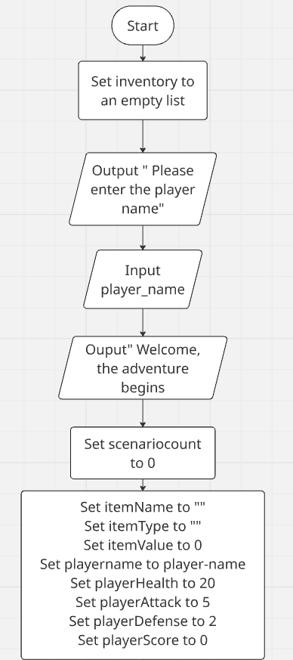
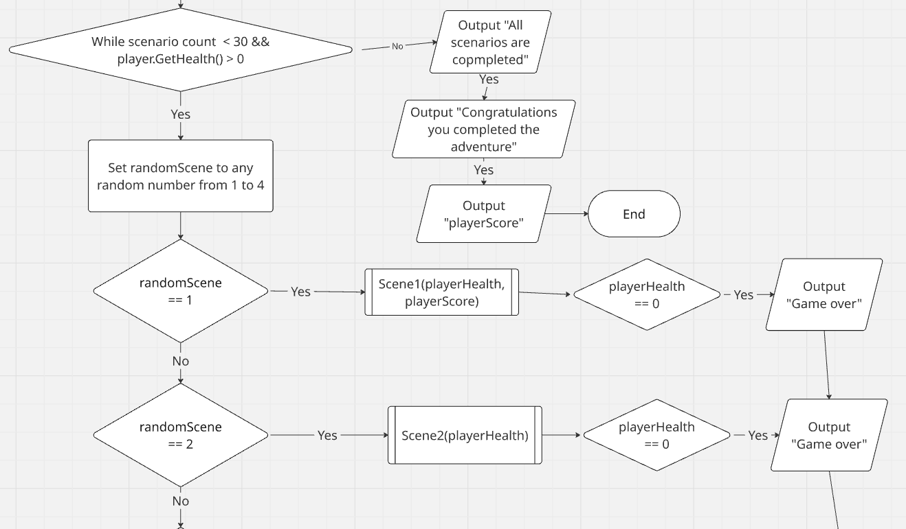

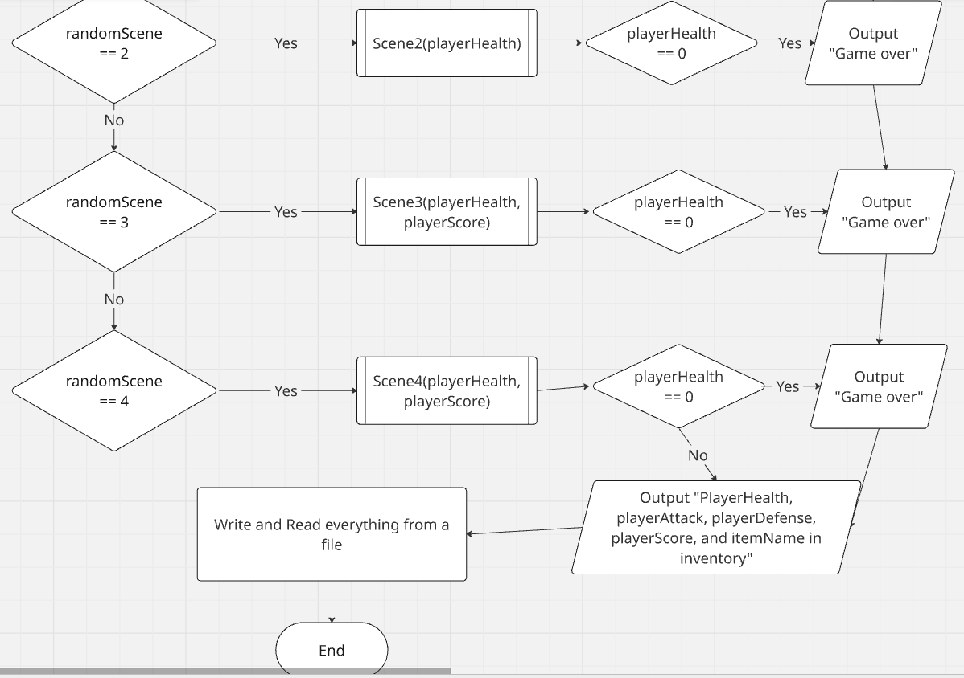
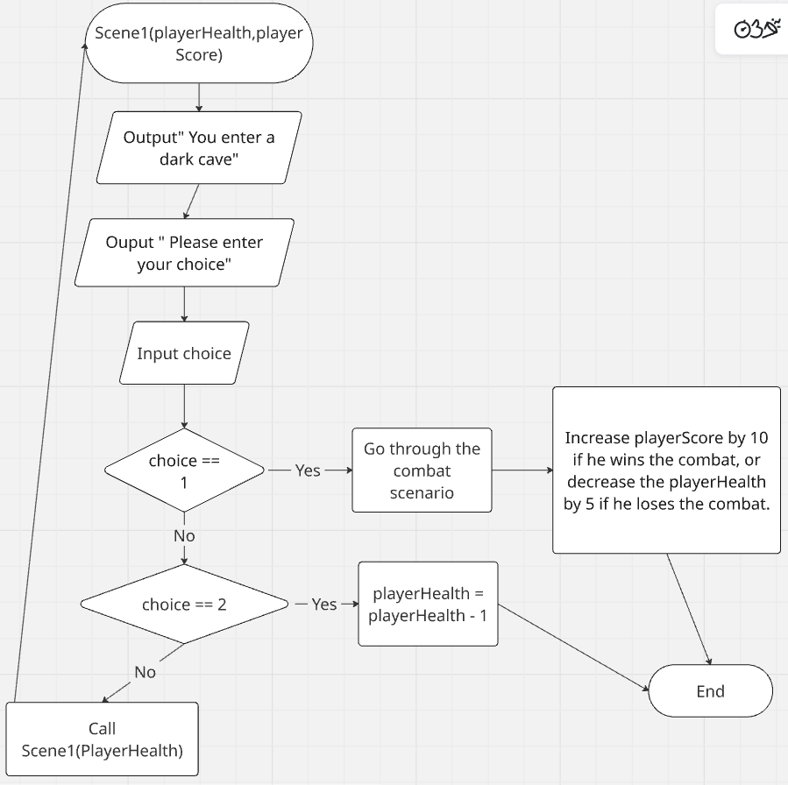

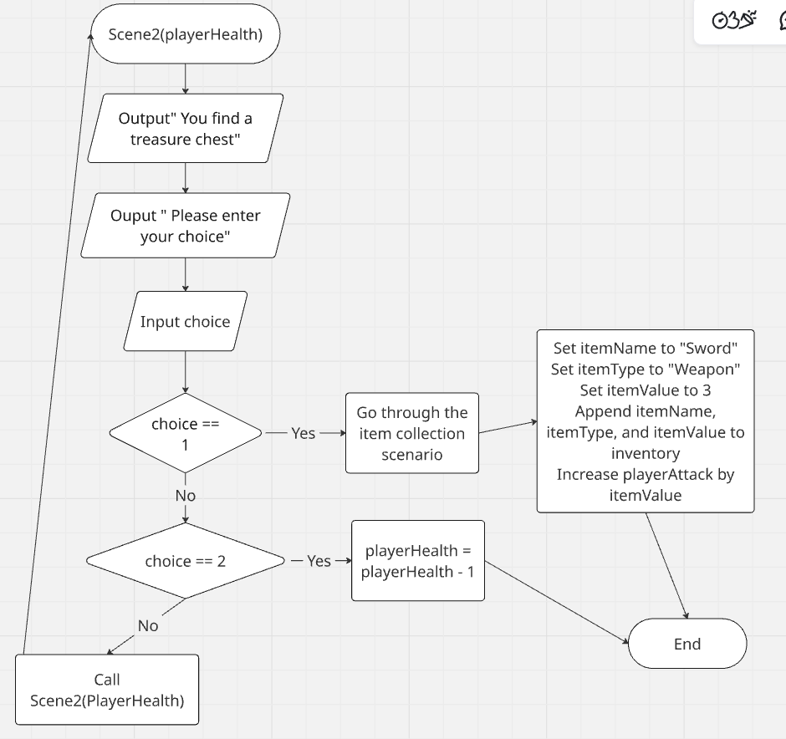

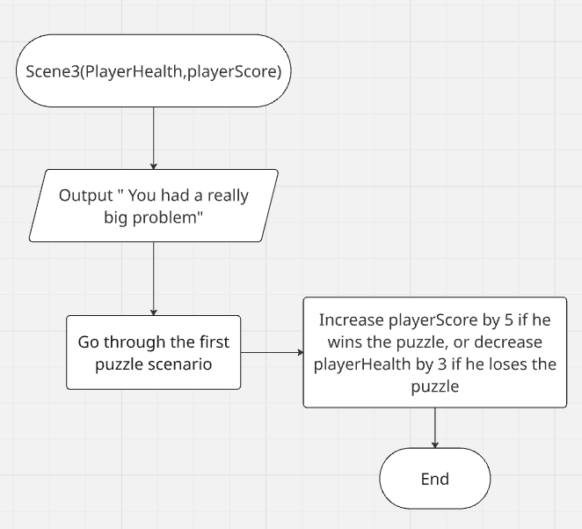

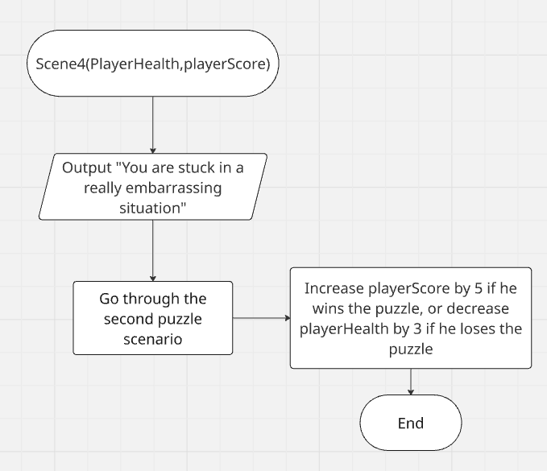
The class diagram:


